**Introduction**

Given the educational goal of this project (for students to simulate the earliest stages of the software lifecycle) and the goal of the course (for CS students to understand that there’s more to successful software engineering than simply writing code), the deployment and maintenance plans will be treated as a single entity of at least 10 pages that must satisfy all requirements for the final exam. This report treats the objectives of the deployment and maintenance plans (described in the final exam outline) as part of a long-term survival strategy for a hypothetical business that is prompted by one question: how would 44T-GR8 (the student team) become an entity that can “generate revenue” – and hopefully “profit” – using the Tower Defense game as its flagship product? To that end, the report will be partitioned into three primary sections:

1. Organizational Strategy – This section will focus on the steps and costs necessary to convert 44T-GR8 from a student team to a legally functional business entity, including the legal status of the business structure(non-profit organization, limited liability corporation, sole proprietorship, etc), acquisition of space of operations (leasing office space, finding an organization that would allow ad-hoc rental of workspace, etc.), generating seed funding to deploy the product. This section will primarily satisfy goals outlined for the “Deployment Plan” portion of the assignment, while ultimately determining the fixed boundaries of the maintenance plan (i.e. if 44T-GR8 becomes a non-profit organization, there are different legal boundaries that constrain our product strategy and maintenance strategy, than if it becomes a for-profit entity).
2. Product Strategy – This section will attempt to define the expected lifespan of the product, how to partition its lifespan to generate the most value to 44T-GR8 as a business, and what actions could be taken at each of those partitions to generate value (promotions, updates, functionalities, etc). This section will mainly satisfy goals outlined for the “Deployment Plan” portion of the assignment, as it will include a modified alpha/beta testing process to match our chosen deployment platform, costs associated with the game testing, and how to structure and schedule functional updates as well as content updates.
3. Survive and Advance – This section will describe how the product strategy should integrated with a monetization strategy to such that 44T-GR8 as a business entity can survive long enough to ensure the product reaches the end of its lifespan without ending the lifespan of the business entity; it will cover most of the goals from the maintenance plan that were not already covered in the previous two sections.

Moreover, to preserve the analogy that has guided this course – that students are employees in a company that are grouped into teams to produce things – without reducing this report to simply a list of costs, it will be assumed that Dr. Gibbons (as CEO of whatever he wants to call the class as a company) will be reading these reports as a corporate decision-maker deciding whether the proposed “business plan” by team 44T-GR8 would warrant “serious consideration” as a candidate to become a subsidiary company within the umbrella of EECS 448 Software Holdings (or whatever he calls it in his head). With this established, the only logical “business model” for 44T-GR8 would be that of an independent development studio established as a non-profit corporation.

**Organizational Structure**

This is the most important portion of this paper. If an organization sets untenable expectations, each sub-structure of the organization becomes a “minefield” of trapdoors that bottleneck institutional progress, as unrealistic expectations inevitably force its members to work under duress. By setting clear institutional goals from the outset, the only possible disruptions to the small, student-run software development entity are the unforeseen (unknown unknowns) and the interpersonally communicative. Due to the “complicated” “intellectual” “property” rules of the University, it would be in the best interest of 44T-GR8 to become a non-profit corporation and behave as such. This would allow 44T-GR8 to be a “student-run studio” without obviously violating restrictions on monetizing projects developed to satisfy course objectives within the University Curriculum, as student developers are “compensated” via a formalized institutional acknowledgment from the University. The students can then use that to generate whatever “value” they wish (on resumes, or maybe to impress strangers at parties). This would create an environment in which students could take “entrepreneurial risks” without risking too much of anything (except time).

**Why nonprofit incorporation?**

The goal of this project is to allow students to be in charge and get a taste of failure without having to eat a full plate of real-world consequences. Establishing a non-profit game studio (44T-GR8) with express permission to affiliate with the University would be a relatively simple process: consult legal counsel to determine how to fill out a *CN 51-02 Not-For-Profit Corporation Articles of Incorporation* (State of Kansas -- Articles of Formation, 2012) form for the state of Kansas without breaking any laws, or setting up the foundations for laws to be broken in the foreseeable future. The University of Kansas provides free legal consultation for students in legal conflicts that do not involve other University of Kansas students or the University itself. As our request for legal service would be a general question about establishing a non-profit corporation with permission (hypothetically) from the University, it becomes unnecessary to speculate on immediate legal fees, as campus resources would fulfill that need. Though, for the sake of completeness, assuming such a conflict of interest would exist, and external legal consultation were necessary to file the articles of incorporation for 44T-GR8, such services could be purchased for roughly $520[1]

**What does this have to do with product deployment or maintenance?**

To think that products can be deployed into a system of pure economy without purpose or cultural context is to live as an automata: every product (and more generally, every action) occurs with an intention. Although the creation of *The Gr8 D# (defense)*, was ultimately invoked to satisfy curricular outcomes – it sought to do so in an entertaining way, thus unwittingly becoming a teaching tool created by another teaching tool (the project itself): to “succeed” in a tower defense game is to do what Stalin, Reagan, and other Dear Leaders failed at – answering the guns vs butter dilemma at different scales[2]. As time progresses in the game, the player must choose to expend their physical resources (literally mashing the button to fire at the enemies from the player-controlled tower) and economic resources (money) and the optimal rate of expenditure to survive both the current situation and what they predict the future situation may be. It is a risk-free exposure to one of the more stimulating and useful intellectual paradoxes: spend resources on value now, or expected value later[3]?

The Tower Defense class of games, particularly ones with primarily geometric themes, grab the attention of adults in the same way they grab the attention of children – there’s a lot of cool looking stuff going on that we don’t really want to look away from, because patterns. When considering that fact and that 44T-GR8 is constrained by the University’s IP policy to profit from the game, it becomes clear that the most “value” could be extracted from *The GR8 D#* via a concurrent, targeted deployment process that targets two audiences: 1. the adults whose money we can take in exchange for their enjoyment of our product and 2. The children who need access to products like this to at least be exposed to resource scarcity and constrained decision-making in a non-Spartan way (so people like us can’t take their money through games designed to exploit the atrophy of focus that’s occurring at this moment in history in the most benign-looking packages – the hyper-connectivity of the “human network,” whatever that means).

To satisfy the operational outcomes desired by the first part of the deployment strategy, *The Gr8 D#* would be deployed via Steam’s Green Light process. The goal of Steam’s Greenlight process is to crowdsource the game-selection process so Valve can save resources to do whatever it is that they do nowadays[4] (Grayson, 2016). To fulfill the requirements of the Greenlight process, a prospective game developer must:

1. Pay a $100 Greenlight submission fee
2. Submit at least 1 video showing gameplay of the game
3. At least 4 screenshots or images of the game
4. A written description of the game along with tentative system requirements.

These requirements can be satisfied trivially by 44T-GR8[5]. The difficulty in deployment through Steam’s Greenlight process comes from generating enough interest within the Steam community to push a game to the necessary threshold for acceptance into Steam. There is no transparent, quantifiable metric for determining when a game has “enough” attention to merit being on steam (Grayson, 2016). Rather, a game must receive what amounts to an arbitrary number of votes until Valve believes that a game has generated an acceptable level of “relative interest” in a game compared to other games in Steam Greenlight (Valve Corporation). There are two ways to achieve this goal – present the game in the existing language of nerds on Steam to until the critical mass of attention is generated, or to change the language entirely. The proposed product strategy seeks to do both.

**Product Strategy**

The “democratic” nature of Steam’s Greenlight process creates a paradox – how do we convince people that our new version of an old idea (the specific tower defense game) is worth possibly investing in (or at least caring enough about to upvote) without them having access to the fun of the game itself? This persuasion ultimately boils down to making people think they’ve played it and loved it, or that they haven’t played it yet, but need to or they’re missing out on something “big”. This begs the question of why people play games.

People play games because they either imagine them to be fun at first sight, or because they’re compelled by something (be it they’re “forced” to play a game by a social obligation, coerced by a friend, or dragged into the game by the unbearable passivity of boredom). The hesitation for people to try anything out of their comfort zone is ultimately eliminated by some form of pressure, a need of some sort. Recent events (Brexit, the Election of Donald Trump, and other machinations of the abyss that is Western Social Media) indicate that people are very vulnerable to vague, comforting words (in palatable packages) that create what literary critic Lauren Berlant calls an “economy of affect,” or an economy of emotion, where the objects determined to be valuable are those that make some groups of people collectively feel some types of things; in particular, she focuses on a concept she terms “Cruel Optimism” -- the situation that occurs when hope and faith in the future are felt and believed as a valuable, and feasible, means of reliving the emotions of the past, to the degree that it becomes the nexus of present culture (Berlant, 2011)[6]. The ongoing catastrophes of public consciousness (the vulnerability to false news, etc) reinforce that this idea (“economies of affect”) is no longer confined to the realm of literary critiques of culture, but that the “affective turn” that occurred in post-structuralist philosophy (and was postulated to be at least tangentially related to economic understandings of choice) can now be quantified by analytic techniques of big data to find what human patterns are associated with what consumption patterns to generate economic value. This, again, seems unrelated to deploying *The GR8 D#*, until you consider that education, games, and the future are fertile grounds for analogies of hope and optimism in a time of great uncertainty – when people turn to things like games to distract them from the realities of the world around them, or even from themselves.

This is how 44T-GR8 can generate value: by being situated in an institutional context of education, which necessarily contains an implicit hope in the future, the status of non-profit corporation attempting to produce games for educational purposes becomes easy to accept as a benign entity, but that does not necessarily mean measurable public interest to the degree that Valve requires for a game to be accepted via their Greenlight process; the Greenlight FAQ page explicitly states that external factors such as critical acclaim and other banal marketing platitudes that can be reduced to “buzz” are taken into consideration when determining what games pass the Greenlight process. Given Valve’s “holistic” selection criteria for Greenlight games, it becomes feasible (doable with little money and some time) to generate this appeal by deploying *The GR8 D#* using a game testing process that deviates from the alpha 🡪 closed and/or open beta 🡪 core release model by performing such testing phases in concordance with a guerrilla social media campaign that emphasizes the importance of cultivating intellectual skepticism and analytical skills under constraints during a time of great historical uncertainty due to the extreme (in magnitude and speed) flows of information available to most people at any given time.

What would this testing structure look like? Traditionally, in small-scale independent development, alpha tests are done by the developers and friends and beta tests are done by a slightly broader network of friends/associated people (but containing a more diverse group of people than in the alpha phase). After each testing phase, feedback is recorded and taken under consideration; bugs are noted and eliminated, and the game is refactored and passed onto the next phase. In our version of this process, the “closed” alpha testing would take place through community outreach events already aimed at increasing student interest in technology and science (or even academics more generally) and by distributing the game to educators interested in alternative pedagogical techniques (with customized skins and models for the appropriate educational context), thus literally letting curious kids and teachers try it and describe what they like, what they dislike, what they would change, and why they would change those specific things. After the testing occurs and information is collected and the game is modified, images, video, and testimonials from participants in the testing process could be used as part of the submission materials for Steam’s Greenlight; through this testing process, the game becomes attached to an urgently necessary optimism at this point in history – the dream that the children of the present will be more intelligent than the adults of the present and past. The narrative becomes more important than the technical minutiae of the game itself, as the idea will become so powerful that the game’s risk of mediocrity is outweighed by the risk of being a member of a social media community that “gives up” on a “narrative of hope” that must really be “believed in” during a time of great crisis like the present[7](the same reason people never really “talk” politics on social media). The process is repeated again for beta-testing, though this time, the game is disseminated to different samples of the same groups (outreach events and “alternative” educators) in addition to more general, localized social networks of left-leaning or center-leaning pockets of cultural spectrum – those that cannot resist but propagate “feel-good” web content. These testing phases will occur in a chronology determined by the time-constraints imposed by which particular version of Steam’s Greenlight process 44T-GR8 decides to submit *The GR8 D#*  under; Valve has two “versions” of the Greenlight process, each for games in differing stages of development (Valve Corporation).

Once the game is deployed via Steam, 44T-GR8 will have access to all the amenities that come with being a Steam game – financial transfer infrastructure will be provided via the Steam store and other Valve infrastructure (Valve Corporation). As mentioned in the introduction of this report, this approach necessarily requires an acknowledgment that the game cannot be maintained for more than a year or two (the time when the members of 44T-GR8 are hopefully no longer at KU because of graduation), which means *The GR8 D#* will be assumed to have a lifespan of one year. To keep interest in the game, *The Gr8 D#*, could implement a leaderboard system that tracks user’s scores and rewards players at different percentiles with custom tower skins, or some other “game-changing” reward. This type of system has not been considered in other portions of the report, as this would require an understanding of how Steam’s User API interacts with everything else, which is beyond the scope of this assignment. Moreover, players could also choose to donate for unique, donation-based skins; each of these could possibly change the theme of the game (from futuristic geometric tower defense to a quirky game of paintball mischief in a park). Additionally, that one year time interval could be partitioned into “seasons” as other leaderboard-based games partition the lifespan of a game, where at the end of each season, new leaderboard skins are released in addition parametrized versions of the economy functions that modify the behavior of the game by introducing more variance to the currently smooth, continuous functions that determine how the economy scales mathematically, so with each update, the metastrategy changes.

**Survive and Advance**

But why do all of this? Why go to such seemingly devious lengths to distribute a game to knowingly manipulate people out of a few dollars here and there, when we can’t even “pay” ourselves as student-workers?

Fun!

Though, not in a sadistic sense. The paradoxical relationships between emotion and reason, present value and expected value, and how they relate to choice are inescapable paradoxes of life generally; they’re sequences of events that, as you experience them, you have no choice but to play with the difficult problems of economic optimization (making the right choice for now that doesn’t destroy the later). The fact that it appears that corporate media and marketing agencies are pivoting towards gaming individual and collective emotions to generate economic value is what prompted such a strange spin on a relatively normal business proposal. Mass media makes it easy to think of life and actions as a game – which is fine, and even useful in some contexts – but when treated purely as a game, it becomes a joke, and that’s unacceptable. Though, if the *The GR8 D#* will neither survive nor advance on its own, what will?

44T-GR8, the non-profit entity loosely affiliated with the University. One of the benefits of non-profit corporation classification in the state of Kansas is that a non-profit corporation has persistent existence, that is, the corporation remains as a legal business entity if the owner or creators leave the company (The Company Corporation, 2016)[8]. This is the ideal structure for an organization concerned with generating only enough revenue to be able to financially support the most barebones necessities such as deployment fees, small events, and unforeseen institutional expenses that will depend on people that can only be there for a year or two at most. This is the best case outcome for a product that’s created within the ambit of the University’s control over IP: that the kind masters of “education” will allow us to use our labor for purely symbolic and “experiential” “value”. The entirety of this proposal was written under the assumption that 44T-GR8 would attempt to avoid as many financial transactions as possible by piggy backing on pre-existing structures (like campus legal consultation, workspace on campus, existing social networks, and crowdsourcing structures more generally) as much as physically possible, so that the only expenditures are the costs of incorporation, the costs of submitting the game to Steam’s Greenlight process, and the cost of purchasing a domain name and hosting an informational web-page. The web-page for the non-profit entity could be registered as a .tech domain through Google’s web domain service for roughly $40 USD per year for periods ranging from 1 to 9 years (Google, 2016). Questions of worker compensation and product scaling seem to be unresolved issues, but not every game needs to “scale” to be a “big value” idea. To that end, this idea, or an idea similar to this one – the establishment of an educational game-focused, student-run, non-profit organization – need not require more than a few volunteers looking to convert their already forced labor into something useful, something to remind some people how you can learn from fun, and to show other, smaller people, that learning can always become fun; because even if the games developed in this course could be monetized in the conventional, for-profit way, it wouldn’t be all that profitable.

The other side of the crowdsourcing, easy-access approach to games via platforms such as Steam has created an oversaturation that makes the likelihood of long-term success for an independent game company lower than it previously has been. (Parker, Whitson, & Simon, 2015). Parker, Whitson, and & Simon found that independent game developers primarily gather funding in piecemeal fashion, thus 44T-GR8’s purely crowdsourced and volunteer model does not appear fundamentally untenable.

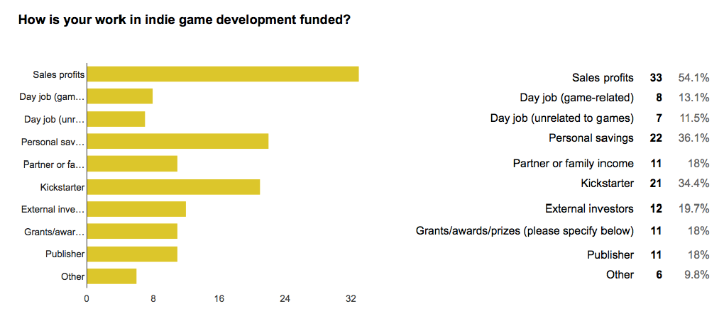

Figure – Indie Game Funding (Parker, Whitson, & Simon, 2015).

Moreover, the ability to recover development expenses seems to be independent of funding source models for indie developers, as shown by the following figure from Parker, Whitson, and Simon’s survey of Indie developers and their satisfaction with their game’s economic performance.

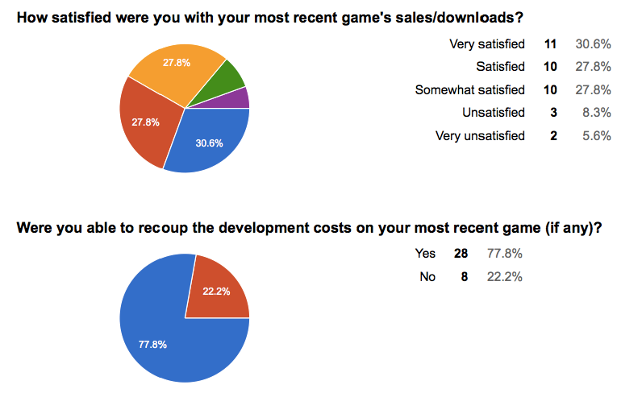

Without profit to look forward to, or fun in creation to enjoy in the present (as *The GR8 D#*  is “complete”), there is nothing left to do but play.

# Works Cited

Berlant, L. (2011). *Cruel Optimism.* Duke University Press.

Google. (2016). Top-Level Domain(TLD) Reference for TECH. Retrieved from https://support.google.com/domains/answer/7080185

Grayson, N. (2016, March 10). Inside The Murky Process of Getting Games on Steam. Retrieved from http://steamed.kotaku.com/inside-the-murky-process-of-getting-games-on-steam-1764091520

Parker, F., Whitson, J., & Simon, B. (2015, December 15). Indie Economics Part 2. Retrieved from http://indiemegabooth.com/indie-economics-part-2/

*State of Kansas -- Articles of Formation.* (2012). Retrieved from Kansas Secretary of State : https://www.sos.ks.gov/other/articles_of_formation.html

The Company Corporation. (2016). *Incorporate by The Company Corporation*. Retrieved from Incorporate: https://www.incorporate.com/package_selection.html

Valve Corporation. (n.d.). Steam Greenlight FAQ. Retrieved from http://steamcommunity.com/workshop/about/?appid=765&section=faq

Zizek, S. (2001). *On Belief -- Thinking in Action.* New York: Routledge.

1. Websites such as Incorporate offer multi-tiered business entity incorporation service packages ranging from $220 (bare minimum completion of incorporation process) to $520 (The Company Corporation, 2016); each tier provides additional ancillary services such as recordkeeping guides and Federal Employer Identification Numbers necessary to open business bank accounts, and so on. As a student run organization, such guiding materials would warrant the extra expenditure.
2. Something that a good programmer should also be able to deal with, if they want to keep a job.
3. Which is what makes algorithm design in general hard, and medical ethics hard, and establishing optimal tax law hard….and so on.
4. Like not telling people that they suffered a breach…for three months. (Grayson, 2016)
5. To “rigorously” generate the tentative system requirements, one would simply monitor resource usage from the The Gr8 D# using the Profiler in the Unity engine as the game is played, then determine reasonable best/average/worst case performance ranges over an interval of time similar in size to the expected duration of a single play-through of The Gr8 Defense. To “loosely” generate tentative requirements, one merely need access to an older computer or multiple older computers and then pick whatever computer specifications run the game at the lowest degree of tolerability (when it starts to look unplayable).
6. Her notion of cruel optimism is primarily concerned with structural injustices resulting from late capitalism and post-colonial development, but one needn’t go that far to understand that people are pretty easily roused into believing first and thinking later, and most of the time, not thinking until it’s too late to fix whatever problem they didn’t know they had.
7. This is what Slovenian Philosopher Slavoj Zizek refers to as “belief in the other’s belief”, when an idea becomes so “true” or believed in by a “critical” number of people that the only real choice becomes to believe in the same or risk a social (or possibly other sort, depending on whether the objects referred to are individuals or nation-states) consequence (Zizek, 2001)
8. In the FAQ dropdown section of the packages web-page, Incorporate describes the benefits of nonprofit corporation status in the state of Kansas.